**LEGO CON**

A **FUN**DRAISING EVENT TO SUPPORT

THE NIGHT OF PEACE

AND

THE BALTIMORE STATION

**CON**

[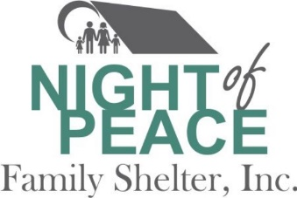](http://www.nightofpeace.org/)[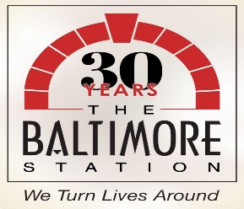](https://baltimorestation.org/)

• MUSIC, GAMES, SPORTS, AND **LEGOS!**

• **DATE**: JULY 20TH

• **TIME:** 1PM-4PM

• **POC:** Cindy Dixon cjd1e@hotmail.com

• **PLACE**: COCKEYSVILE MIDDLE SCHOOL 10401 Greenside Dr. Cockeysville MD

• **Admission Fee**: $1 per person – All proceeds will benefit Night of Peace and The Baltimore Station!

* Donate to:

<https://www.gofundme.com/legocon-night-of-peace-family-shelter>

<https://www.gofundme.com/legocon-the-baltimore-station>